Mark B. Landon, MD
Richard L. Meiling Professor and Chairman
Department of Obstetrics and Gynecology at Ohio State University College of Medicine

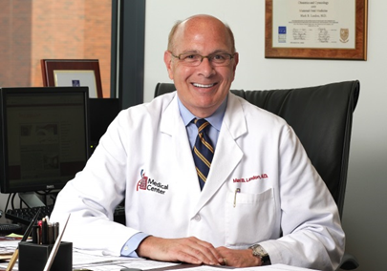
An internationally recognized authority on diabetes in pregnancy, Dr. Landon has published over 250 original articles and book chapters. He served for over twenty-five years as Ohio State’s co-investigator for the National Institutes of Child Health and Human Development Maternal Fetal Medicine Units Network. In this capacity, he has been the principal investigator of several multicenter studies and led the largest prospective treatment trial ever conducted for gestational diabetes mellitus. He is an editor for the 7th Edition of Gabbe, Niebyl, Simpson’s Obstetrics: Normal and Problem Pregnancies, a textbook to which he has contributed for the past twenty-five years.

